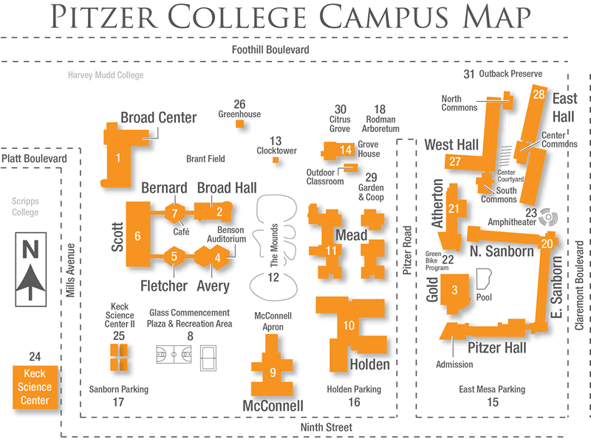

**2014 Hall**

**New Pitzer Gardens Area**